NUKALA MANIKANTA REDDY ASSESSMENT
Python command questions
1.print Hello world
CODE&OUTPUT
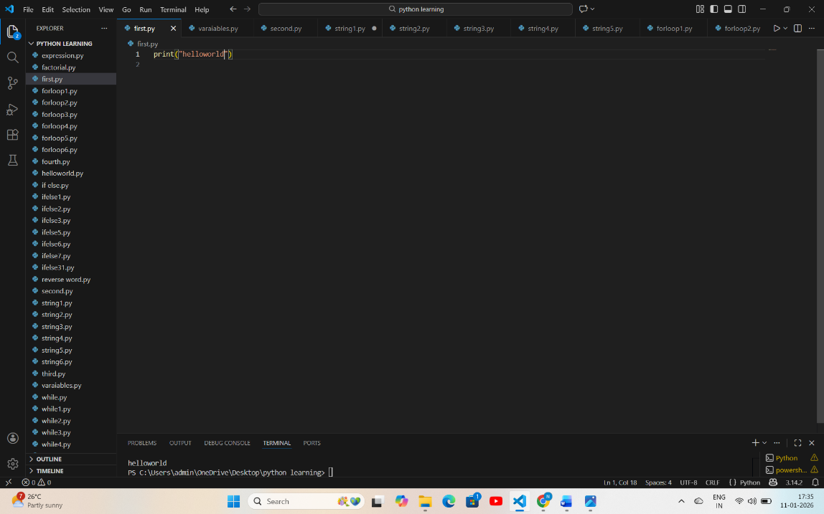
PSEUDOCODE:
START
Print hello world
END
FLOWCHART
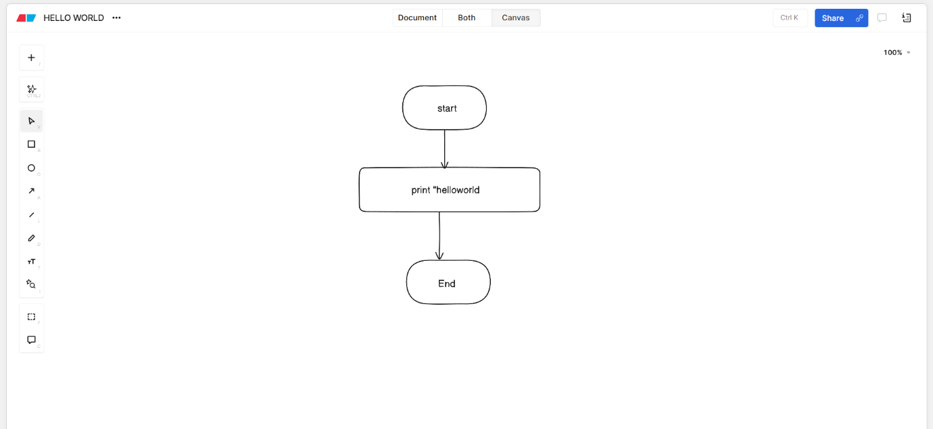
2.Print Python is Fun
CODE&OUTPUT
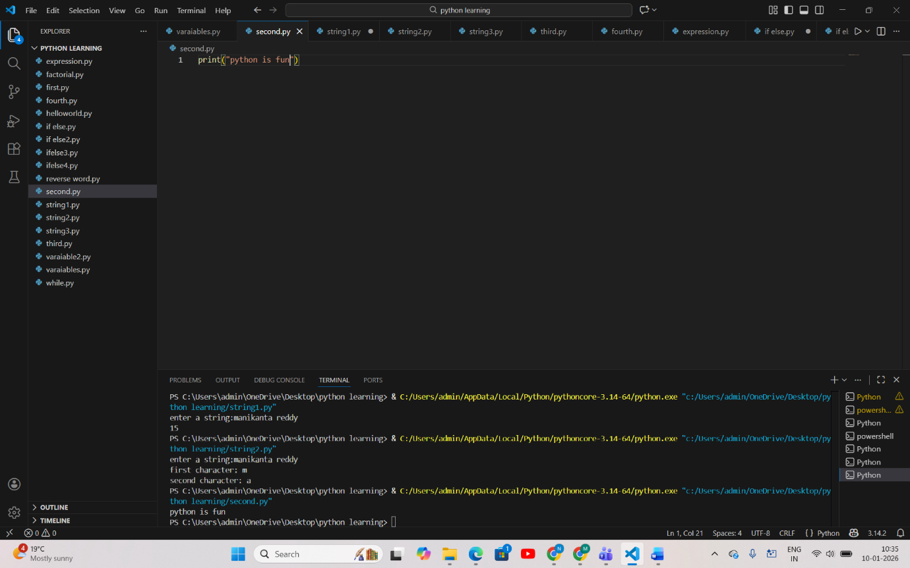
PSEUDOCODE:
START
Print python is fun
END
FLOWCHART
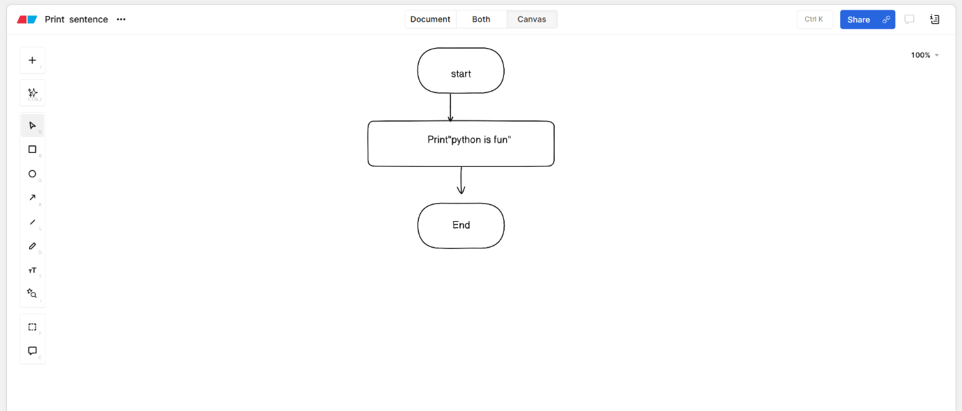

3.print name, age, city
CODE&OUTPUT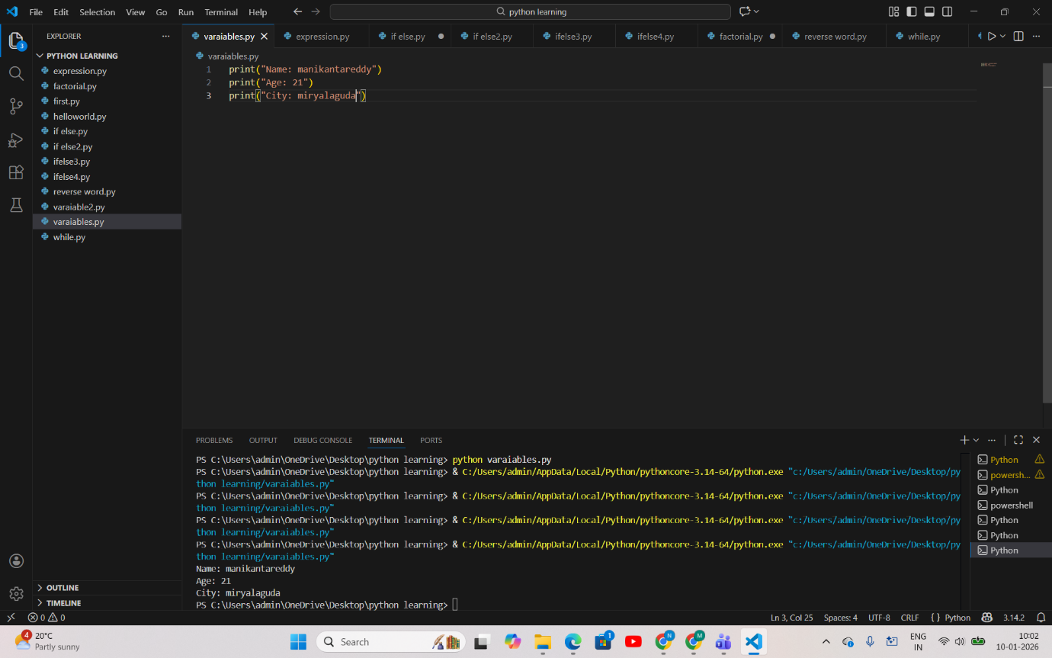
PSEUDOCODE
START
Print “name”
Print “age”
Print “city”
END
FLOWCHART
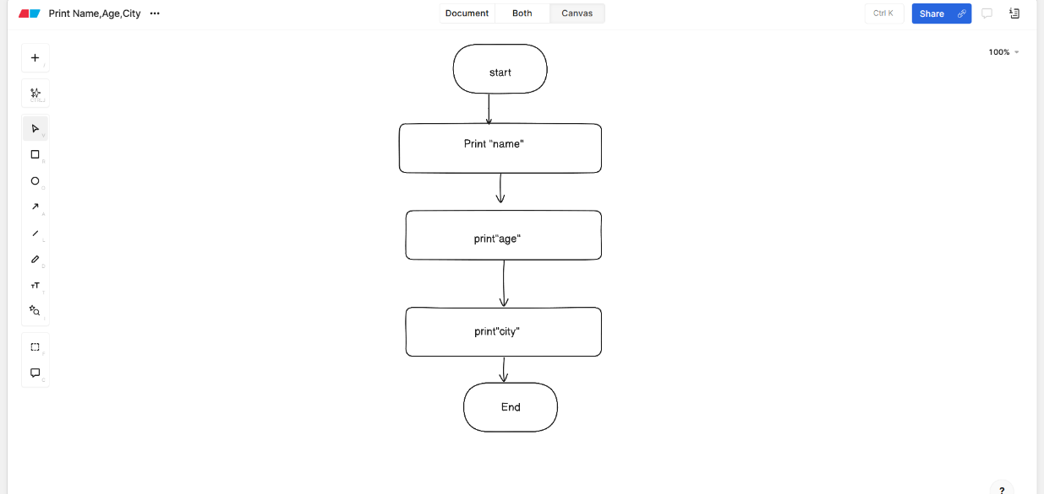
4.print 10+20
CODE&OUTPUT
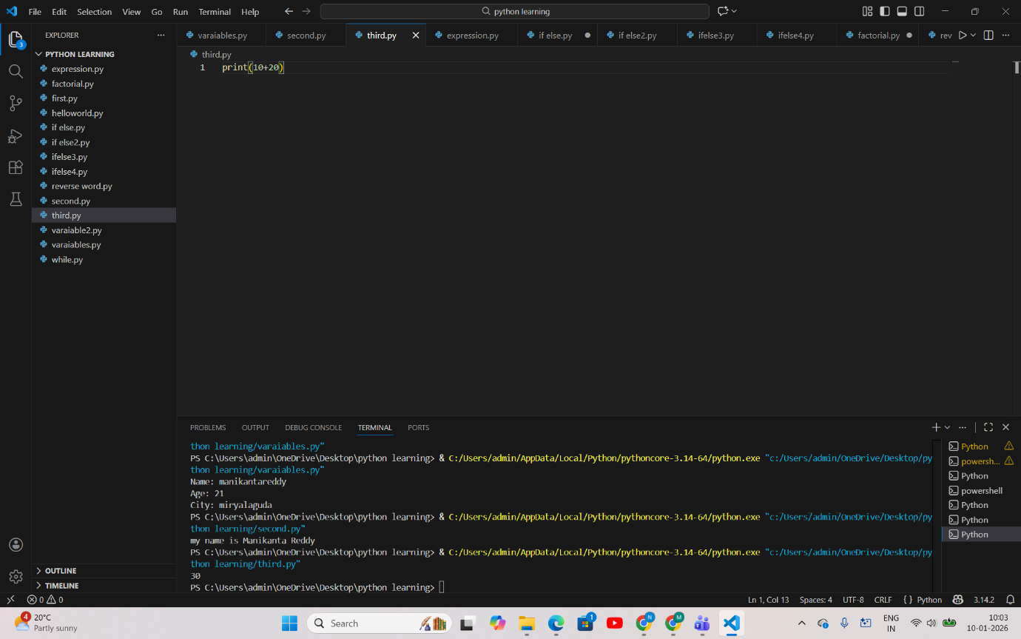
PSEUDOCODE
START
SET Sum=10+20
PRINT sum
END
FLOWCHART

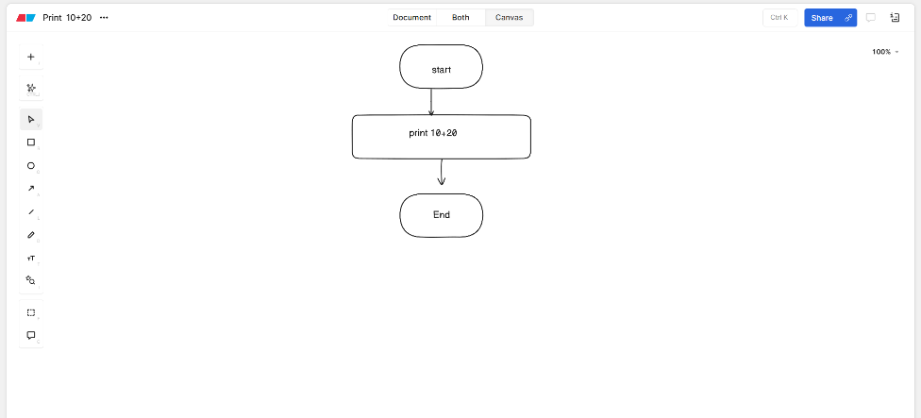

5.Print Pattern
CODE&OUTPUT
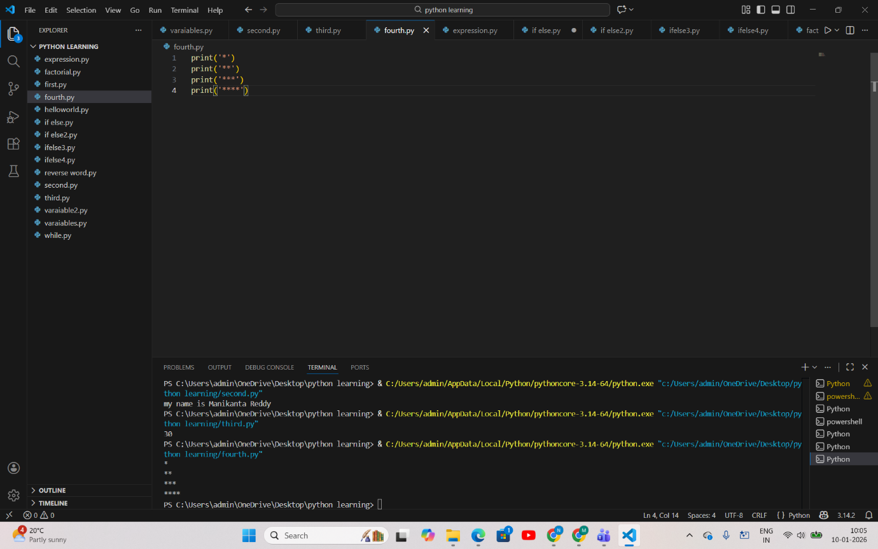
PSEUDOCODE:
START
PRINT "*"
PRINT "**"
PRINT "***"
PRINT "****"
END
FLOWCHART:
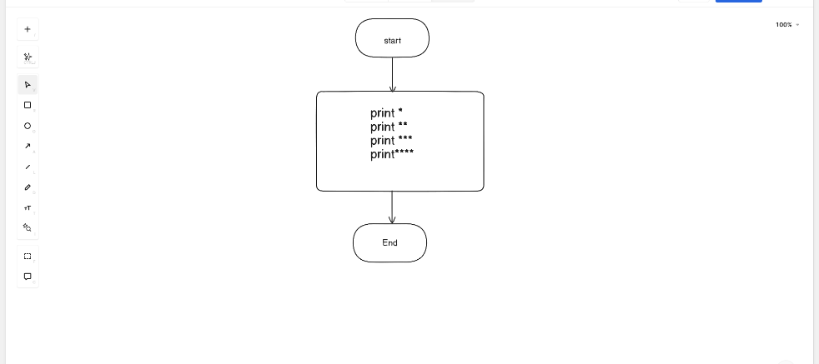

String based Questions
1.Length of the string
CODE&OUTPUT
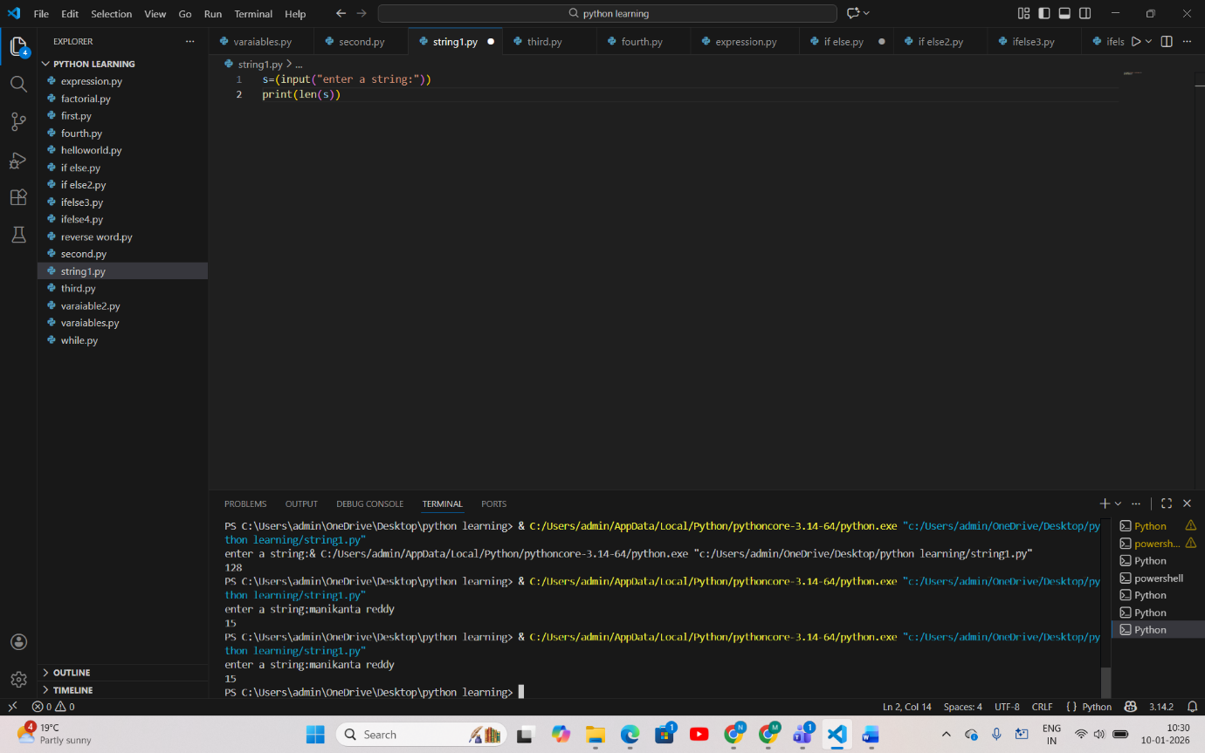
PSEUDOCODE
START
INPUT str
length = LENGTH(str)
PRINT "Length of the string “
END
FLOWCHART
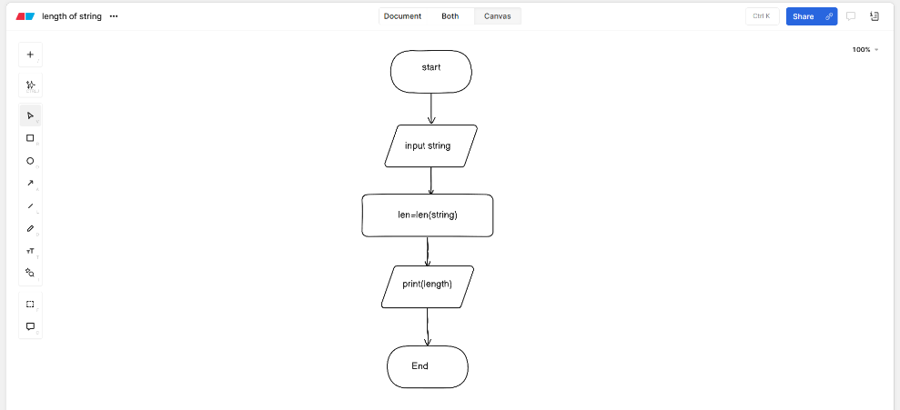
2.Print first and last char of string
CODE&OUTPUT
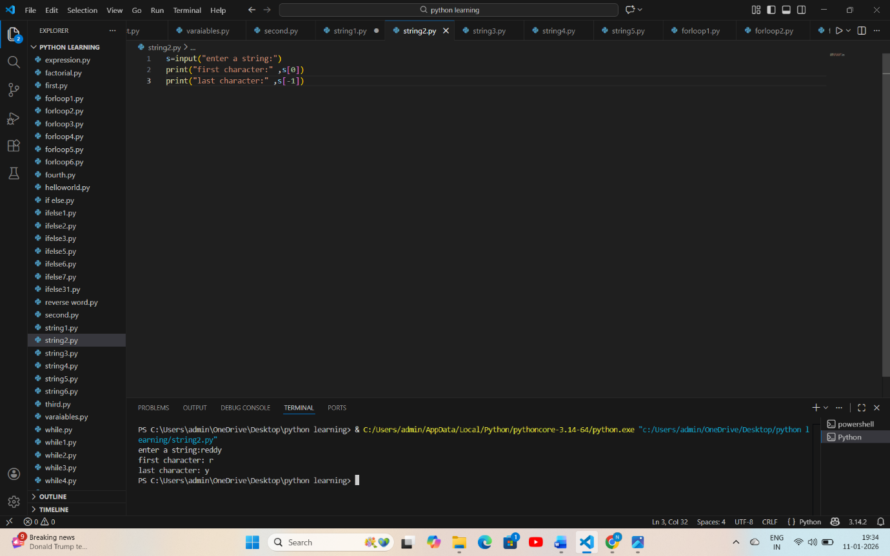
PSEUDOCODE:
START
Ask the user to enter a string
Get the string from the user
Take the first character of the string
Take the last character of the string
Display "First character:" and the first character
Display "Last character:" and the last character
END

FLOWCHART

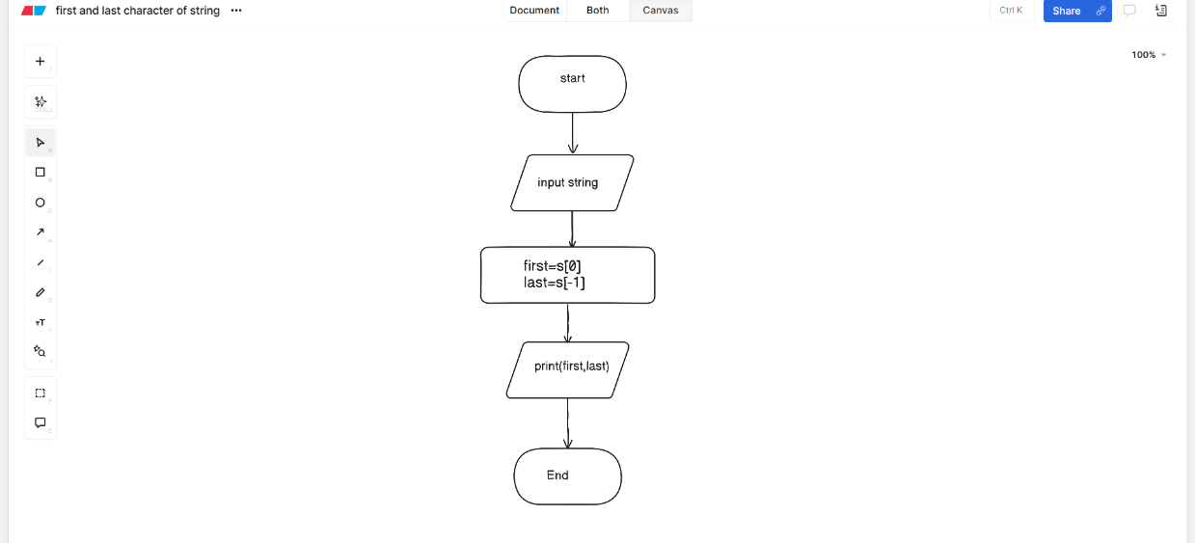
3.Reverse the string
CODE&OUTPUT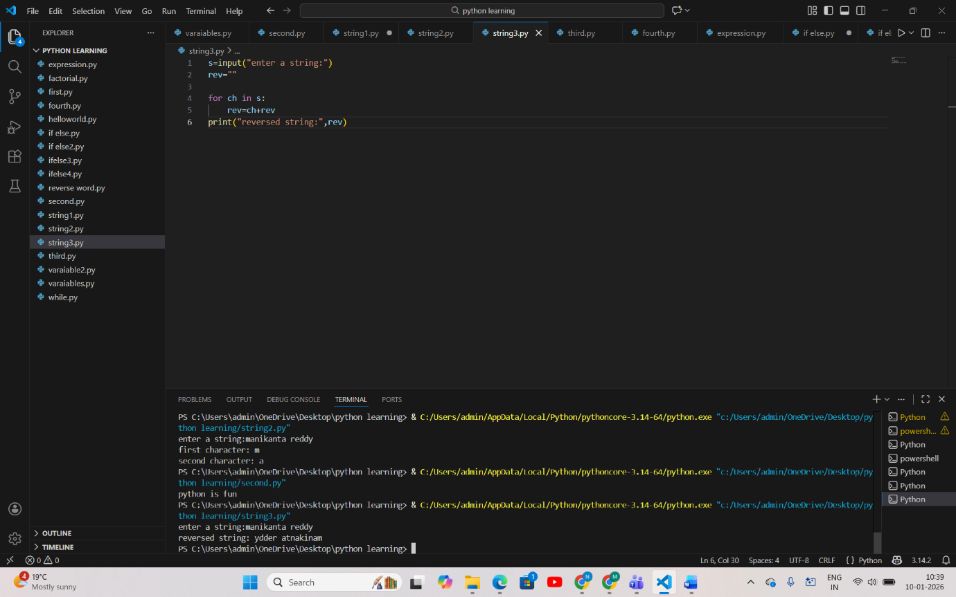
PSEUDOCODE
START
INPUT s
SET rev ← empty string

FOR each character ch in s DO
rev ← ch + rev
END FOR

PRINT "reversed string:", rev
END
FLOWCHART
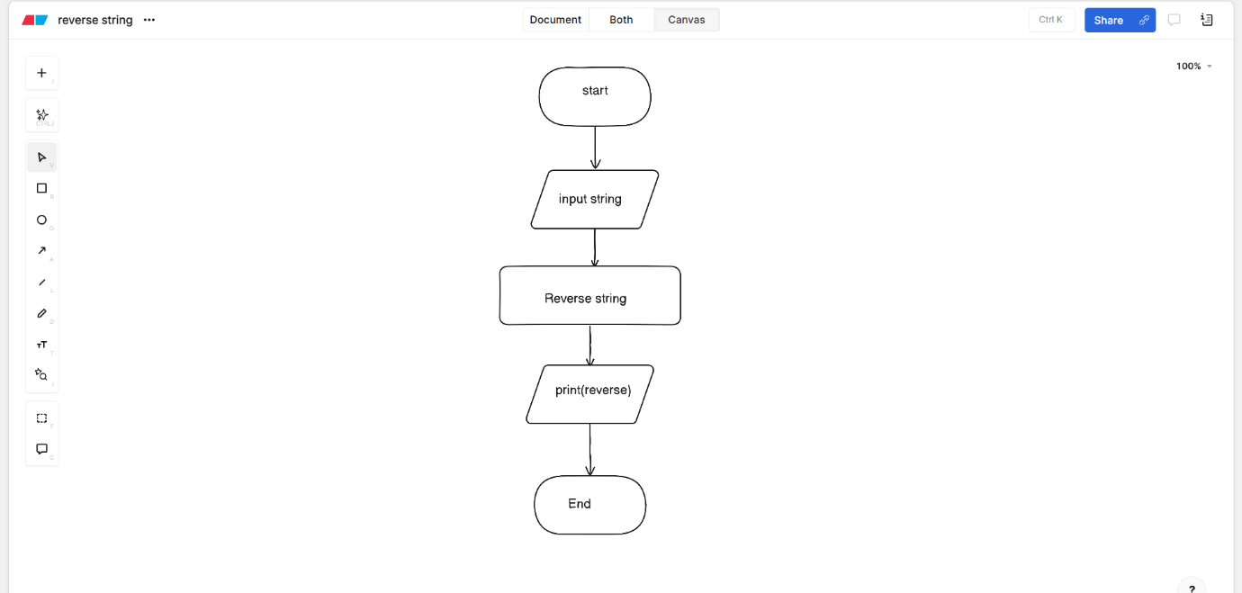

4.palindrome
CODE&OUTPUT
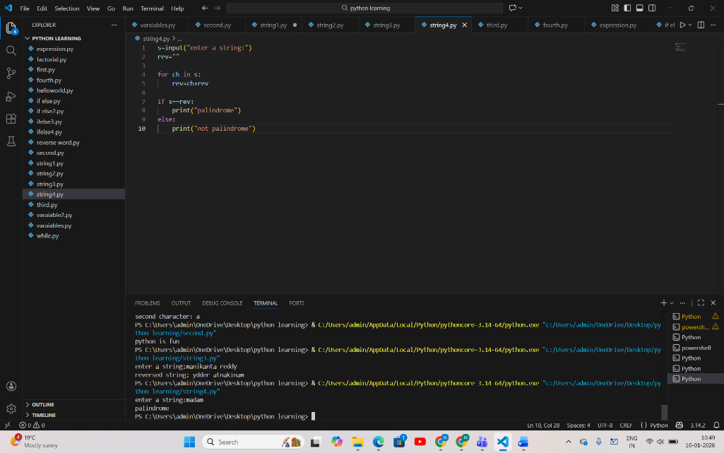

PSEUDOCODE:
START
INPUT s
SET rev ← empty string
FOR each character ch in s DO
rev ← ch + rev
END FOR
IF s = rev THEN
PRINT "palindrome"
ELSE
PRINT "not palindrome"
END IF
END
FLOWCHART
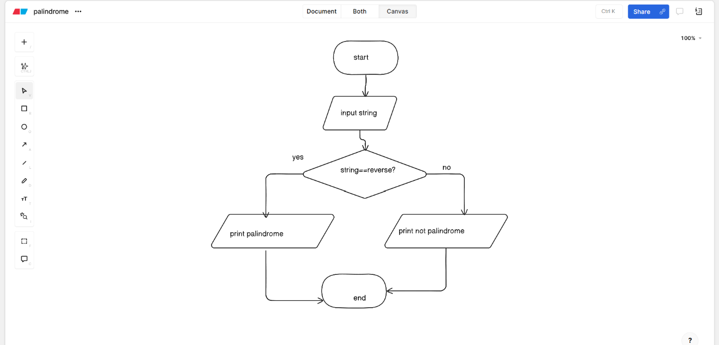

5.Count no of vowels
CODE&OUTPUT

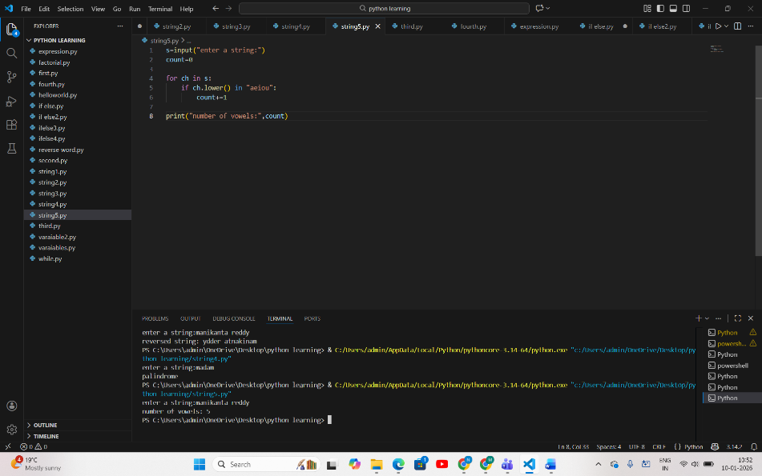
PSEUDOCODE
START
INPUT s
count ← 0

FOR each character in s
IF character is a vowel
count ← count + 1
END IF
END FOR

PRINT count
END

FLOWCHART
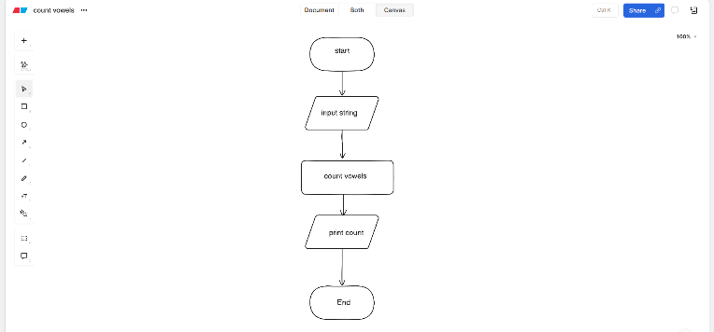
6. Uppercase and lowercase
CODE&OUTPUT
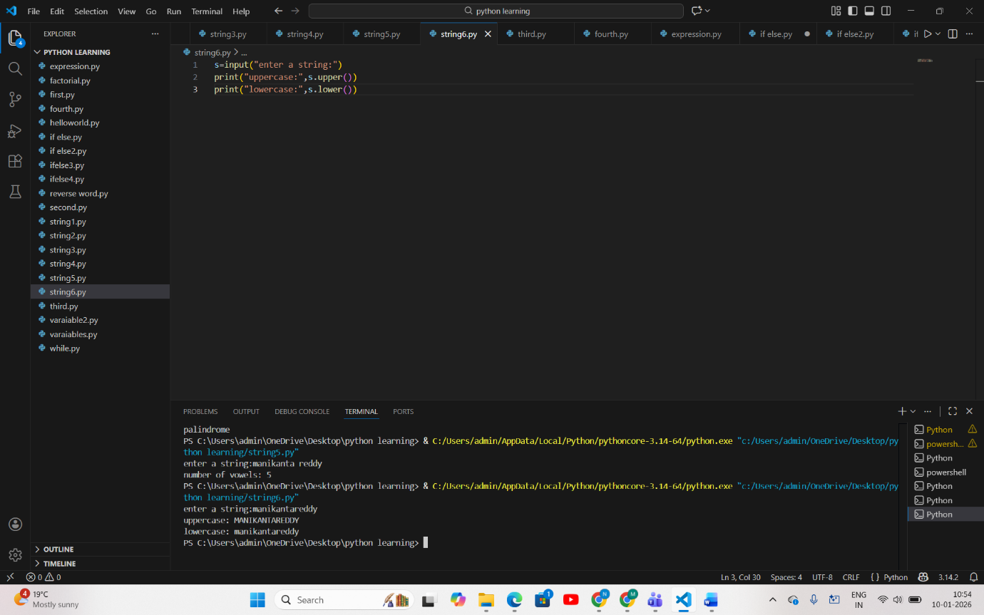
PSEUDOCODE:
START
INPUT s
PRINT uppercase of s
PRINT lowercase of s
END

FLOWCHART:
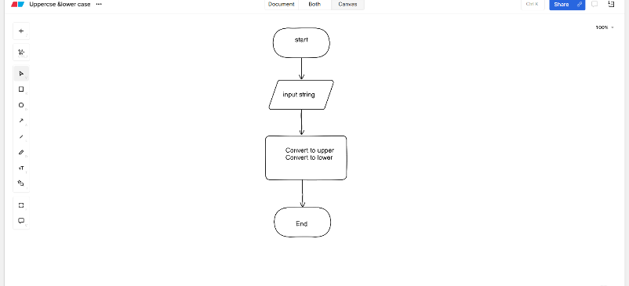

1.Print the numbers from 1-20 using for loop
CODE&OUTPUT
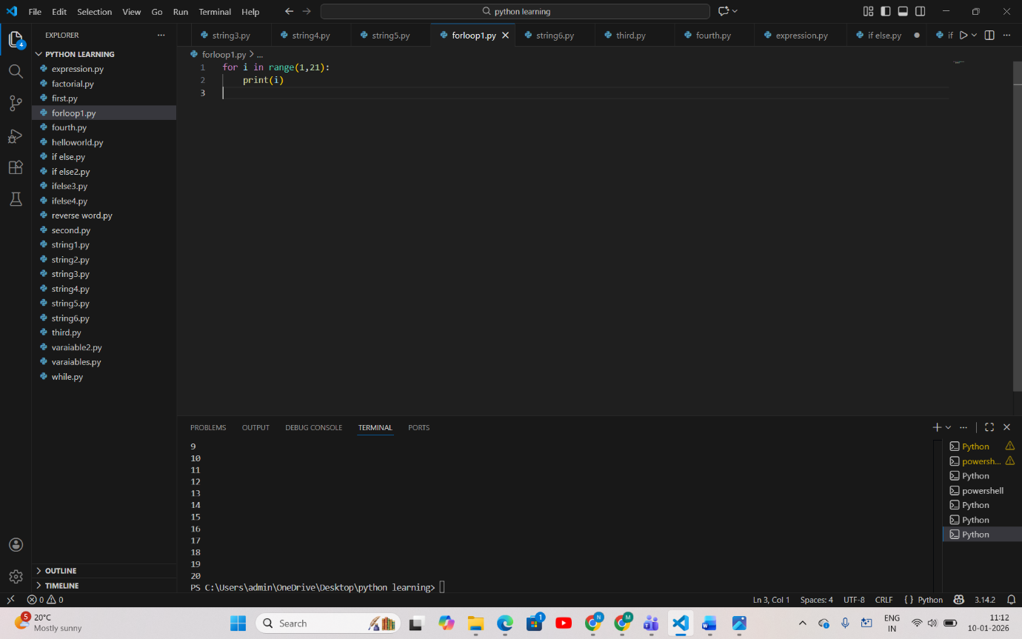
PSEUDOCODE:
START
FOR i from 1 to 20
PRINT i
END FOR
END
FLOWCHART
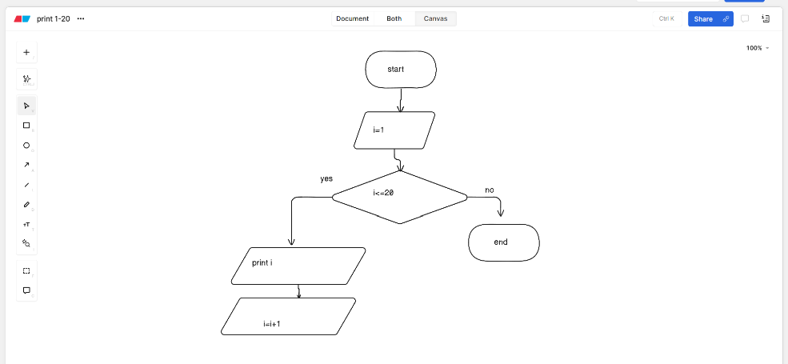

2.Print all even numbers up to 50
CODE&OUTPUT
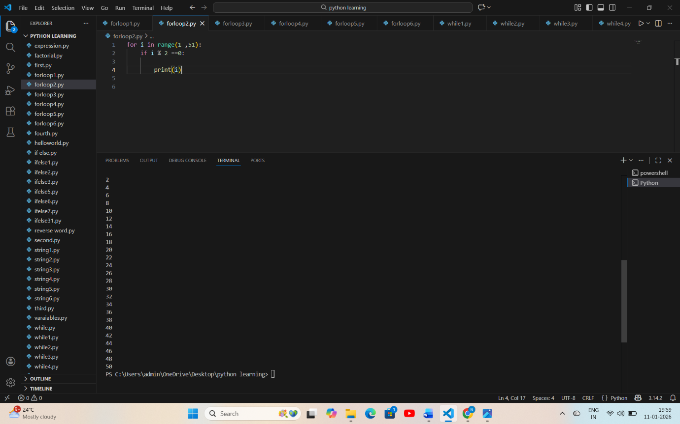
PSEUDOCODE:
START
FOR i from 1 to 51
IF i is even
PRINT i
END IF
END FOR
END

FLOWCHART
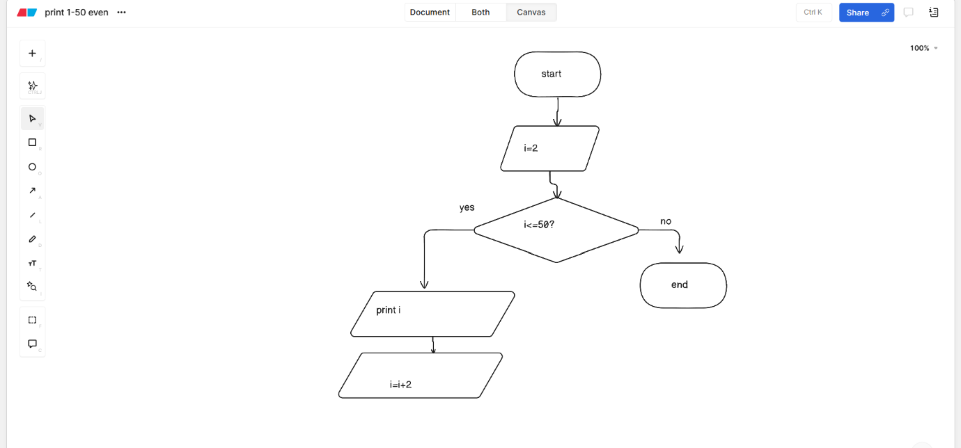
3.Print each char in string
CODE&OUTPUT
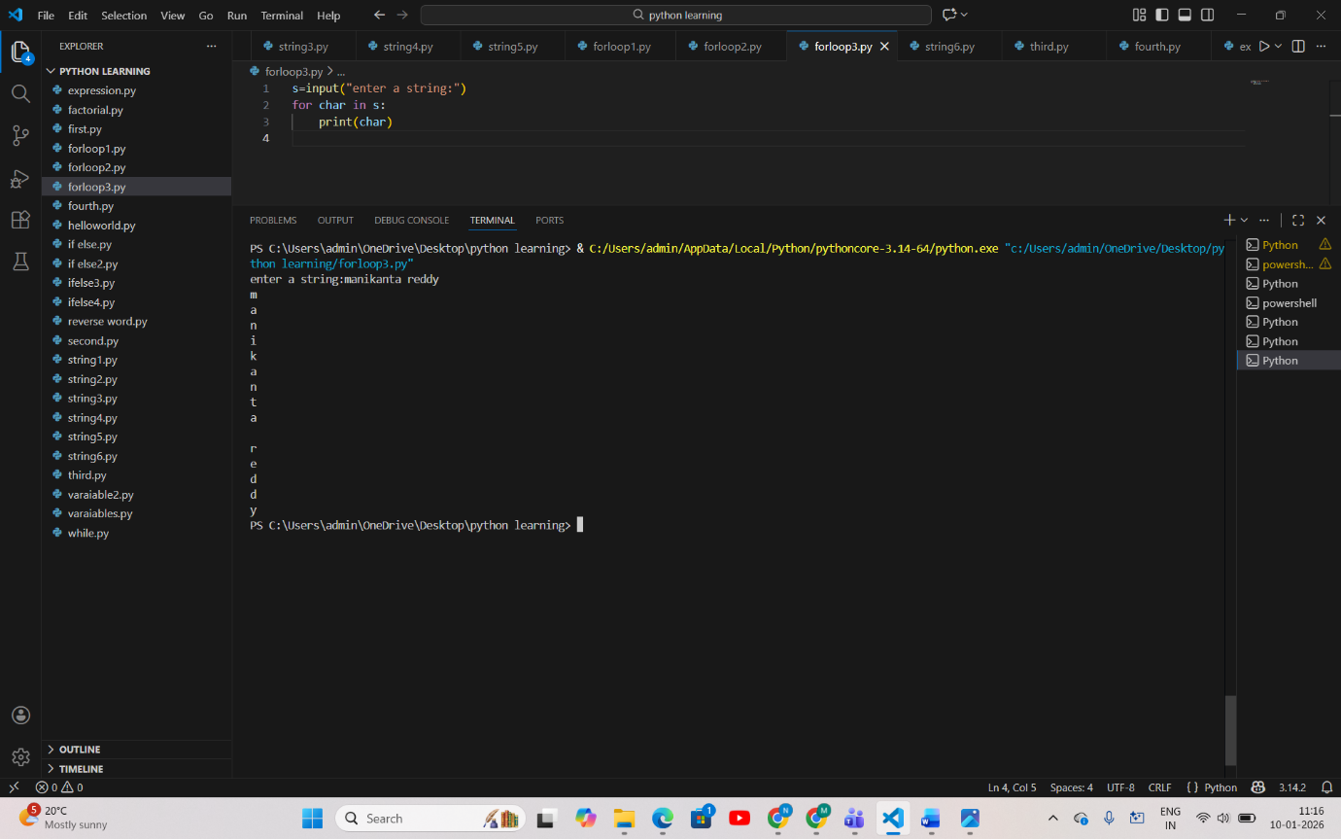
PSEUDOCODE
START
INPUT s
FOR each character in s
PRINT character
END FOR
END

FLOWCHART
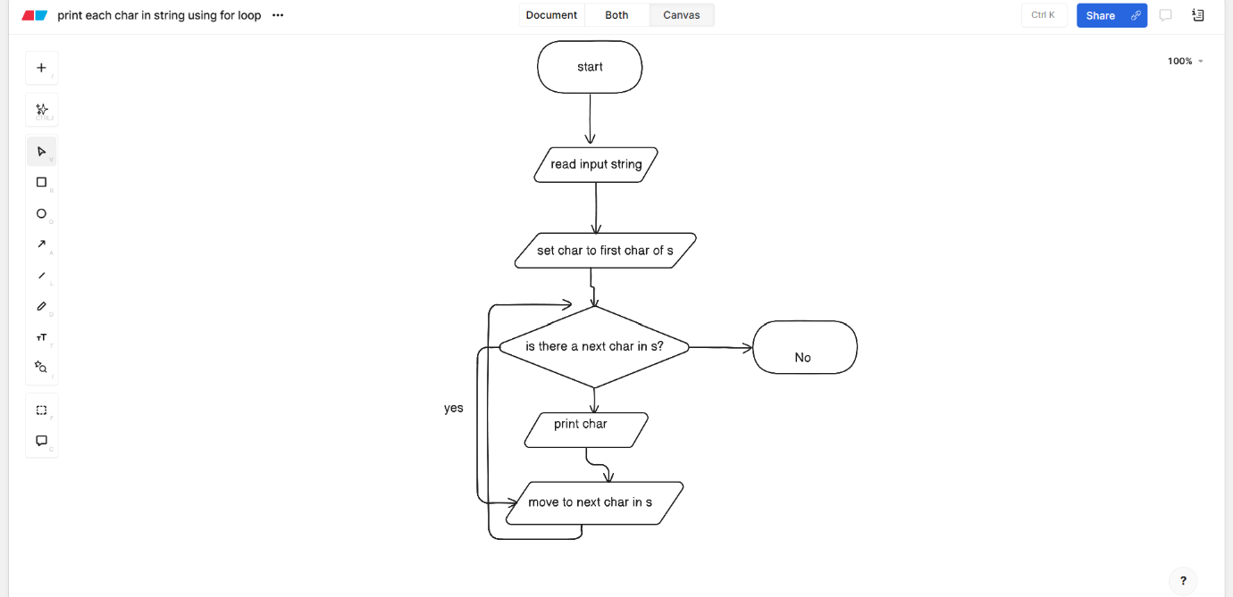
4.Print total sum of a number
CODE&OUTPUT
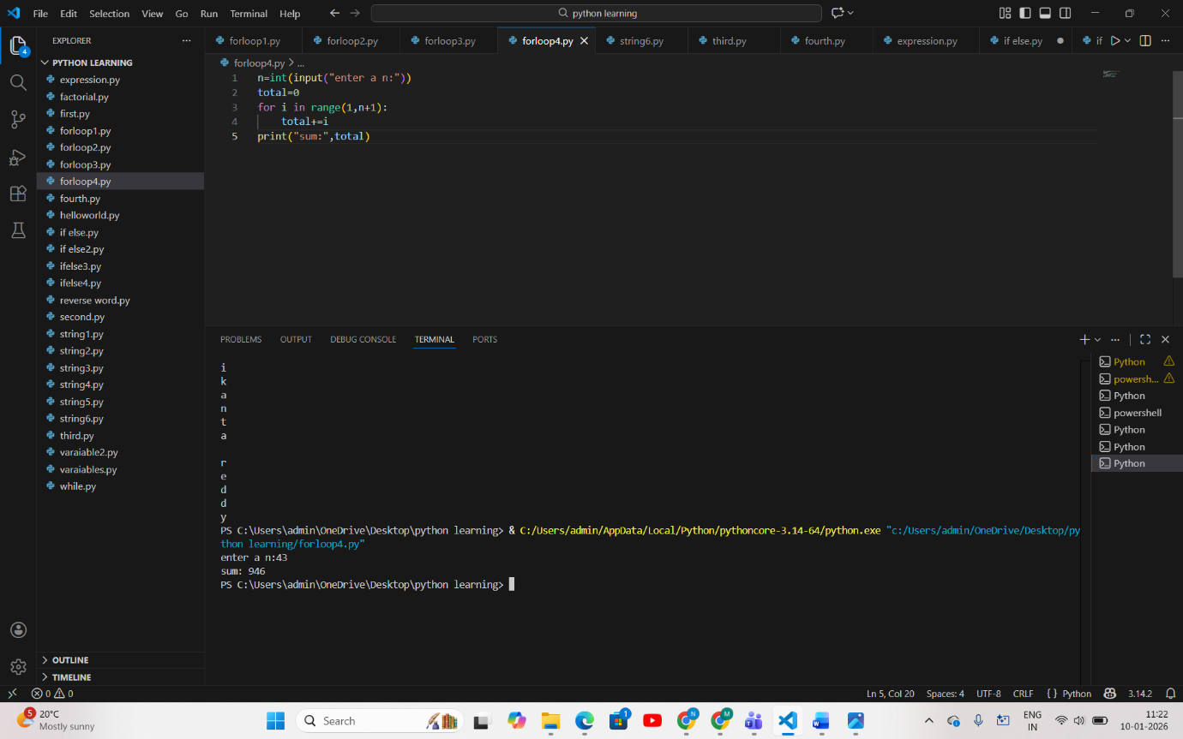
PSEUDOCODE
START
INPUT n
total ← 0
FOR i from 1 to n
total ← total + i
END FOR
PRINT total
END

FLOWCHART
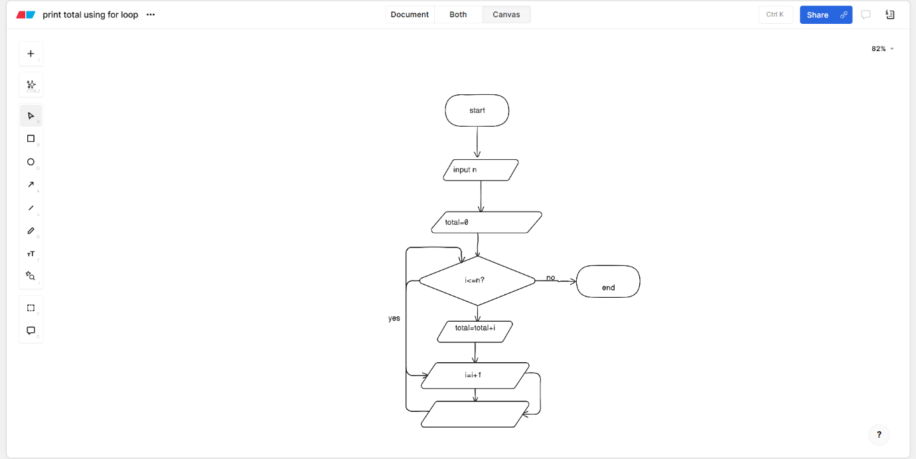
5.Print char appear in the string
CODE&OUTPUT
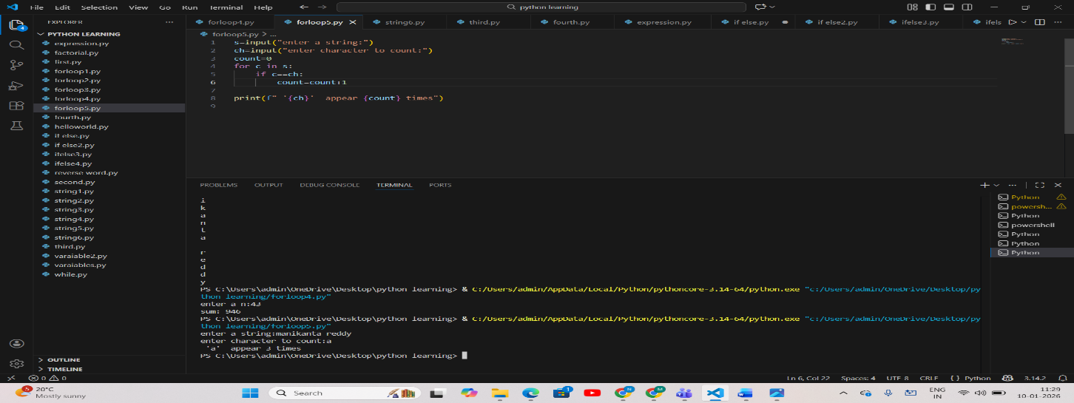
PSEUDOCODE
START
INPUT s
INPUT ch
count ← 0

FOR each character c in s
IF c = ch
count ← count + 1
END IF
END FOR

PRINT count
END
FLOWCHART
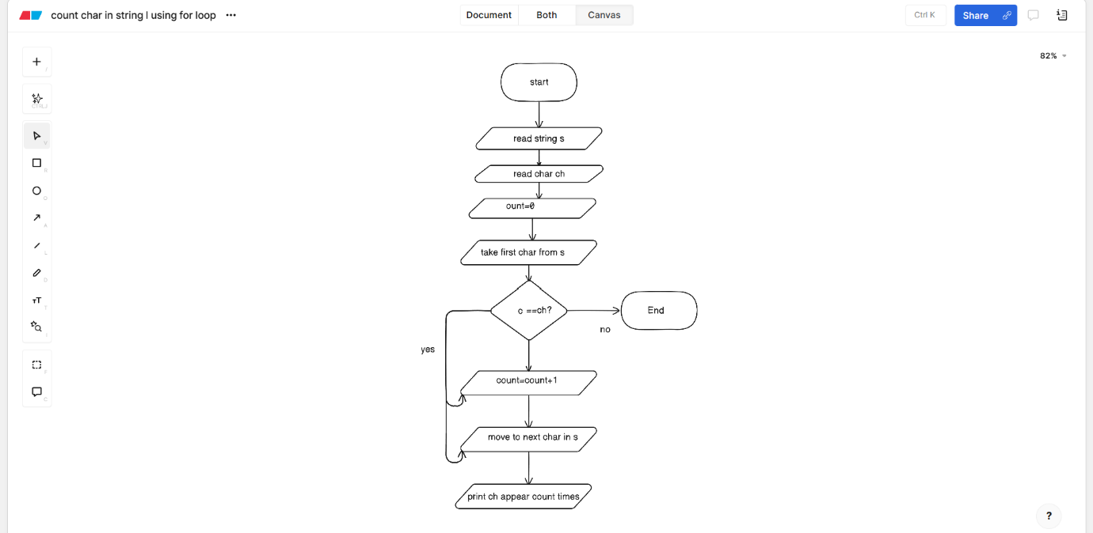

6.Print the pattern
CODE&OUTPUT

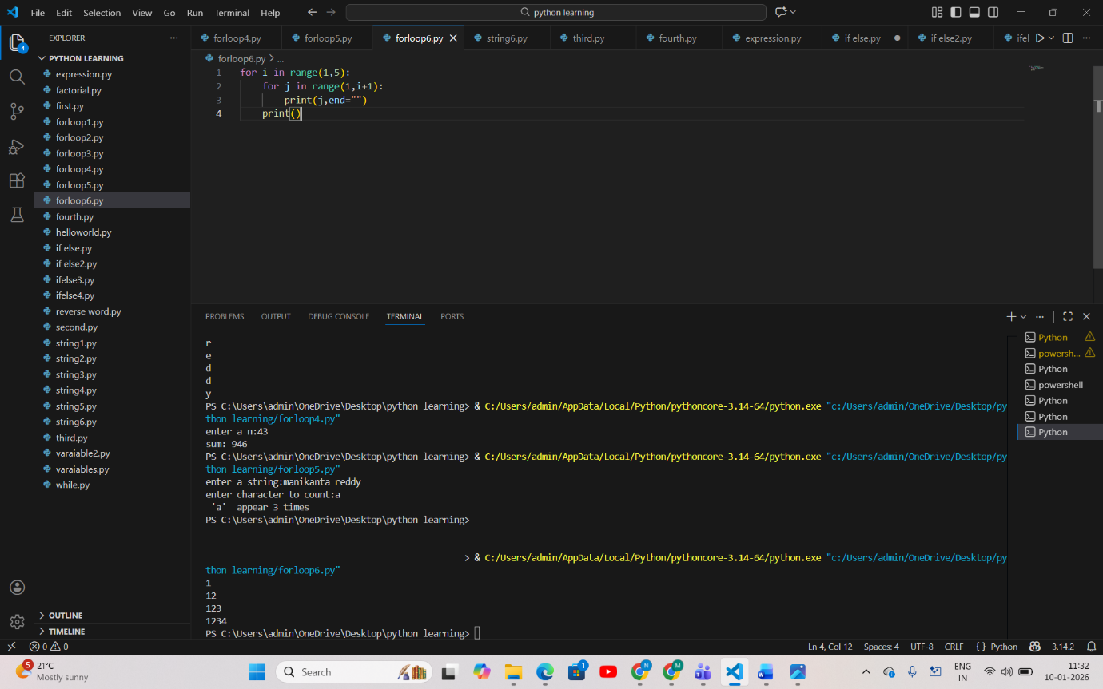
PSEUDOCODE
START
FOR i from 1 to 4
FOR j from 1 to i
PRINT j without new line
END FOR
PRINT new line
END FOR
END

FLOWCHART

1.print leap year using if else
CODE&OUTPUT
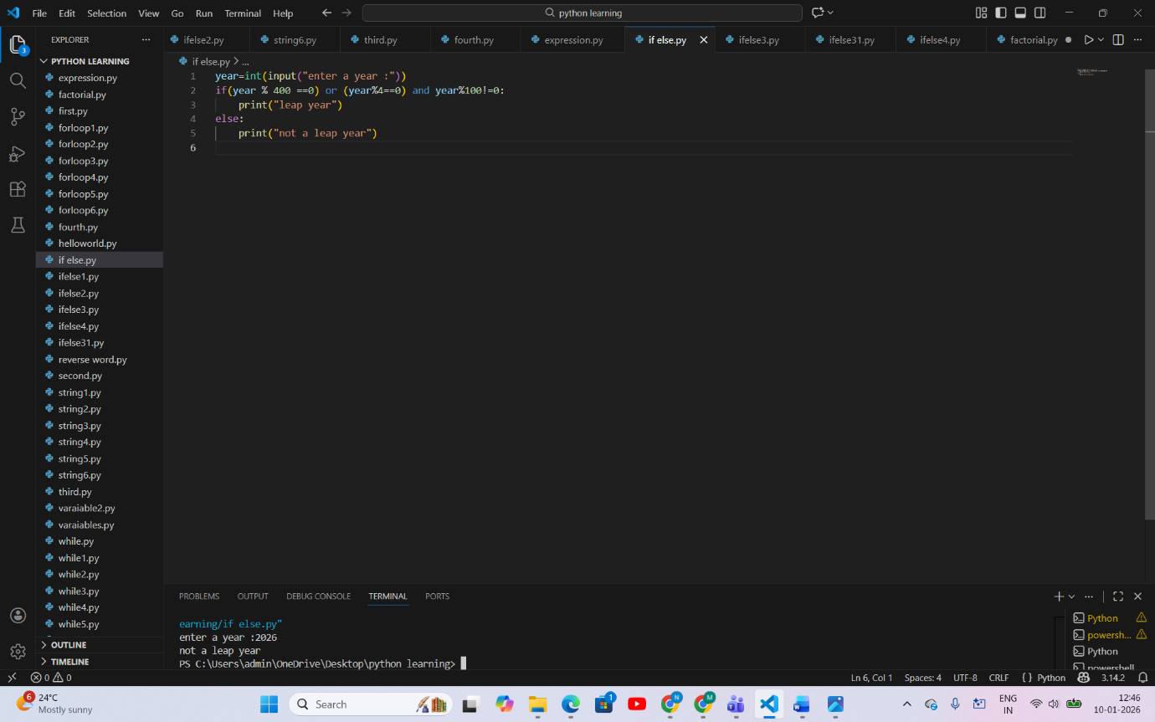
PSEUDOCODE
START
INPUT year

IF (year divisible by 400) OR (year divisible by 4 AND not divisible by 100)
PRINT "leap year"
ELSE
PRINT "not a leap year"
END IF

END

FLOWCHART

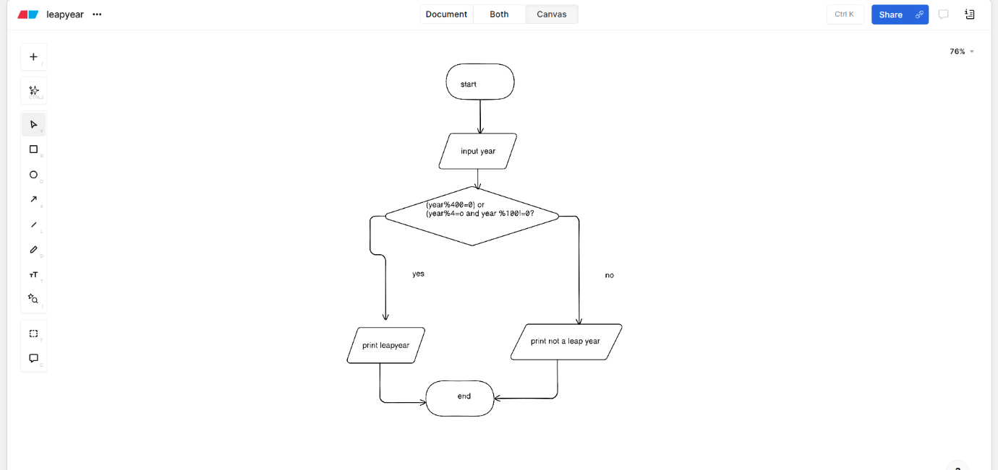
2.Print positive ,negative and zero number using is else
CODE&OUTPUT
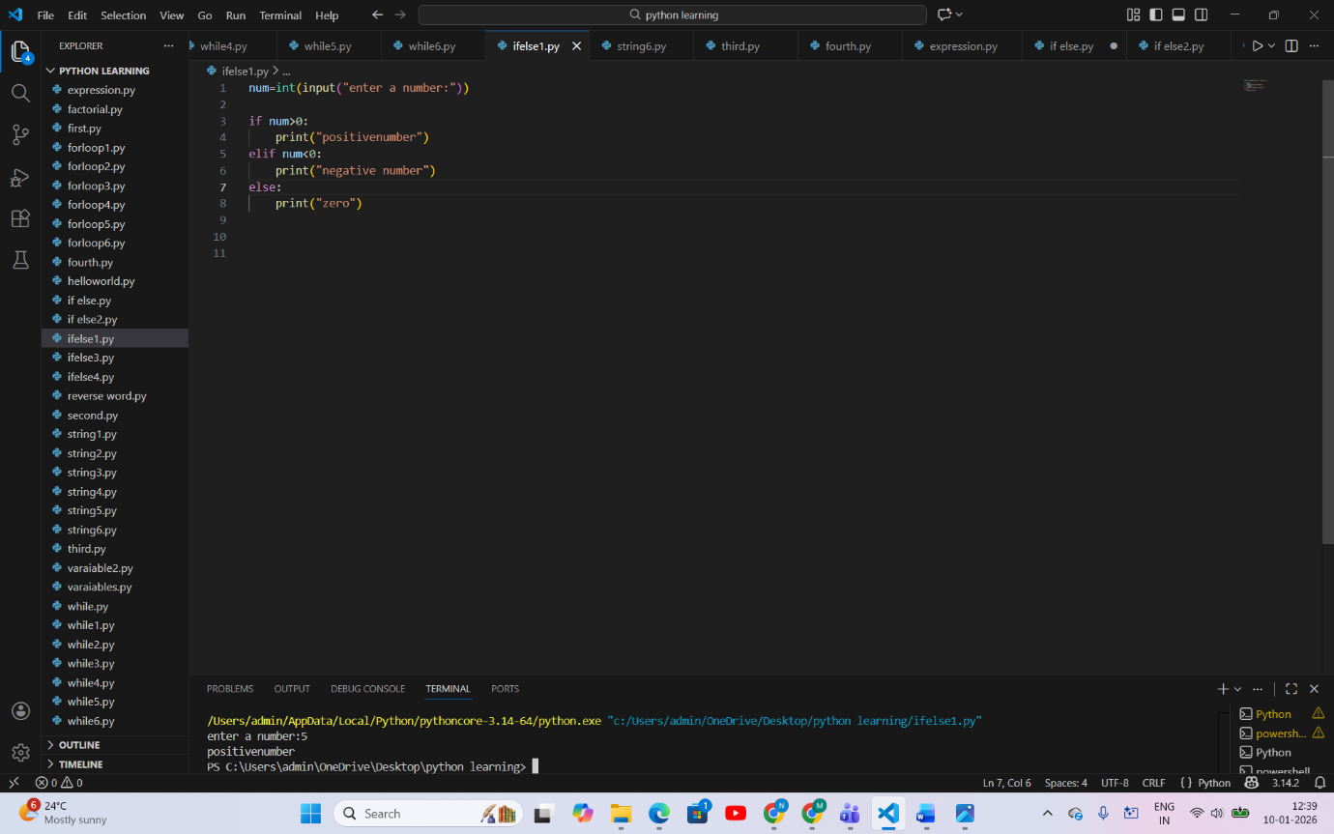
PSEUDOCODE
START
INPUT num

IF num > 0
PRINT "positive number"
ELSE IF num < 0
PRINT "negative number"
ELSE
PRINT "zero"
END IF

END

FLOWCHART
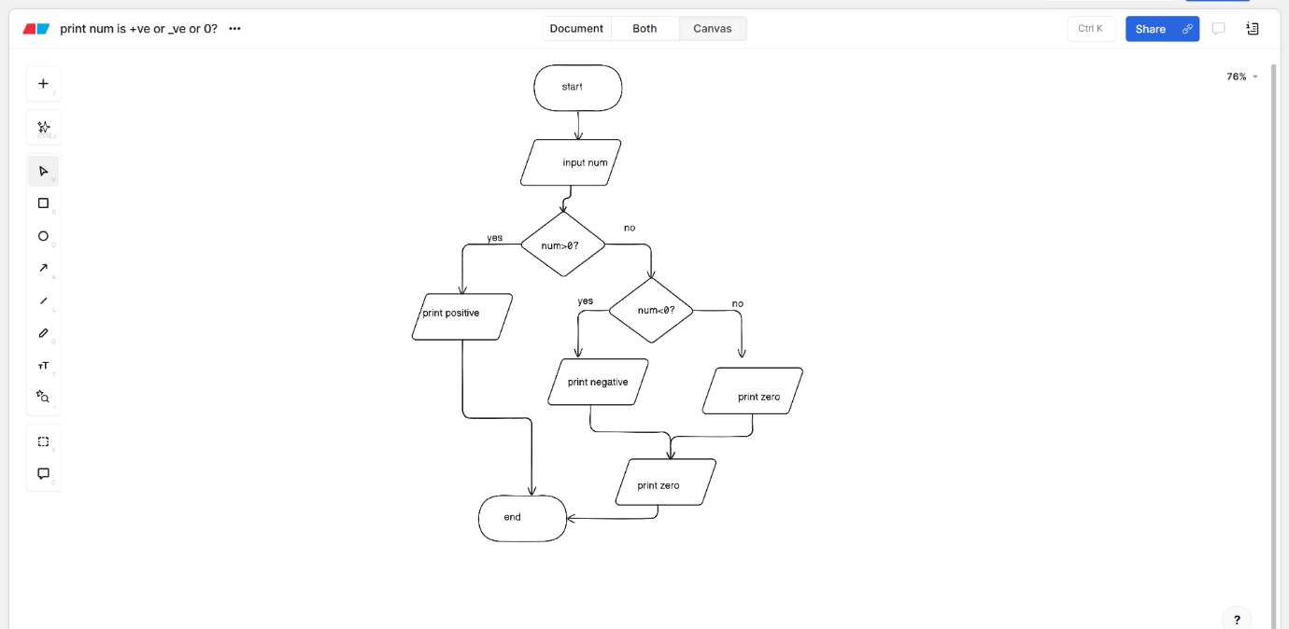
3.Print the marks of student pass/fail
CODE&OUTPUT
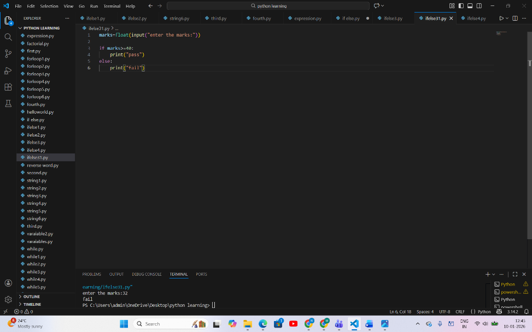
PSEUDOCODE
START
INPUT marks

IF marks >= 40
PRINT "pass"
ELSE
PRINT "fail"
END IF

END

FLOWCHART
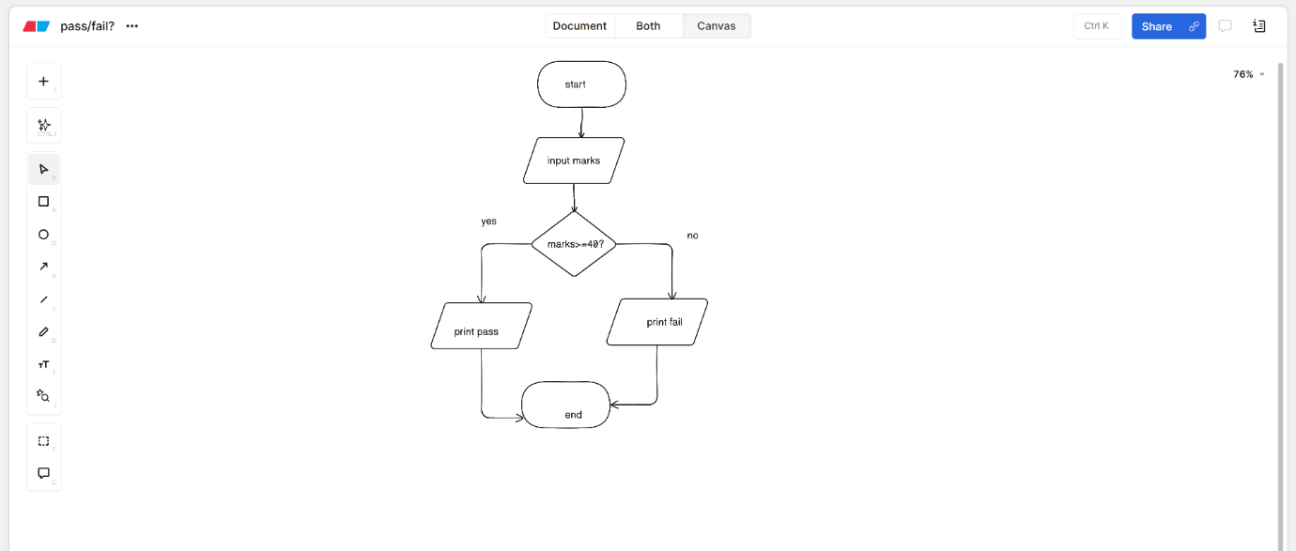

4.Print the number is odd/even
CODE&OUTPUT
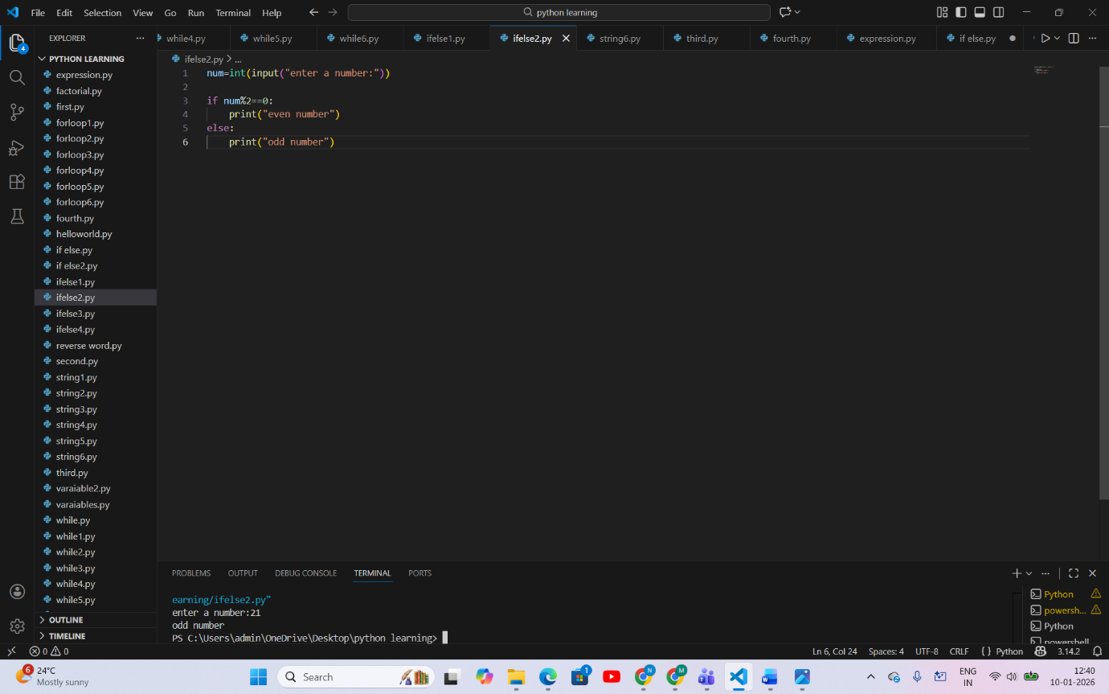
PSEUDOCODE
START
INPUT num

IF num mod 2 = 0
PRINT "even number"
ELSE
PRINT "odd number"
END IF

END

FLOWCHART

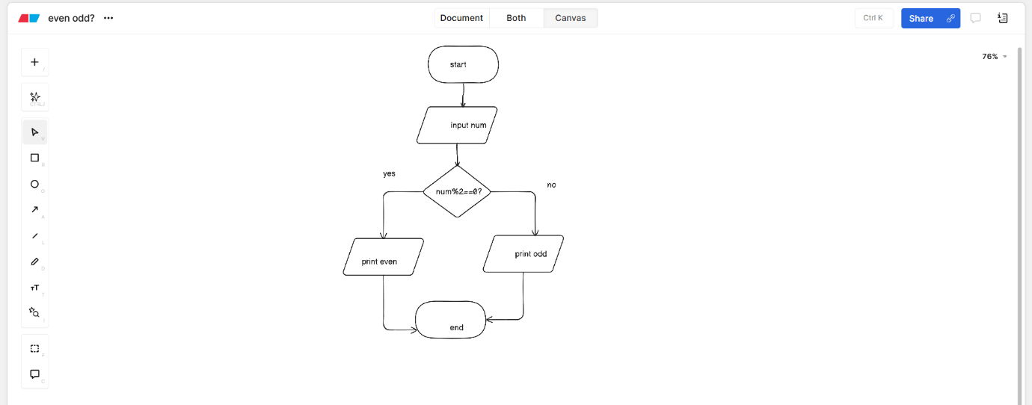
5.Print the largest number
CODE&OUTPUT
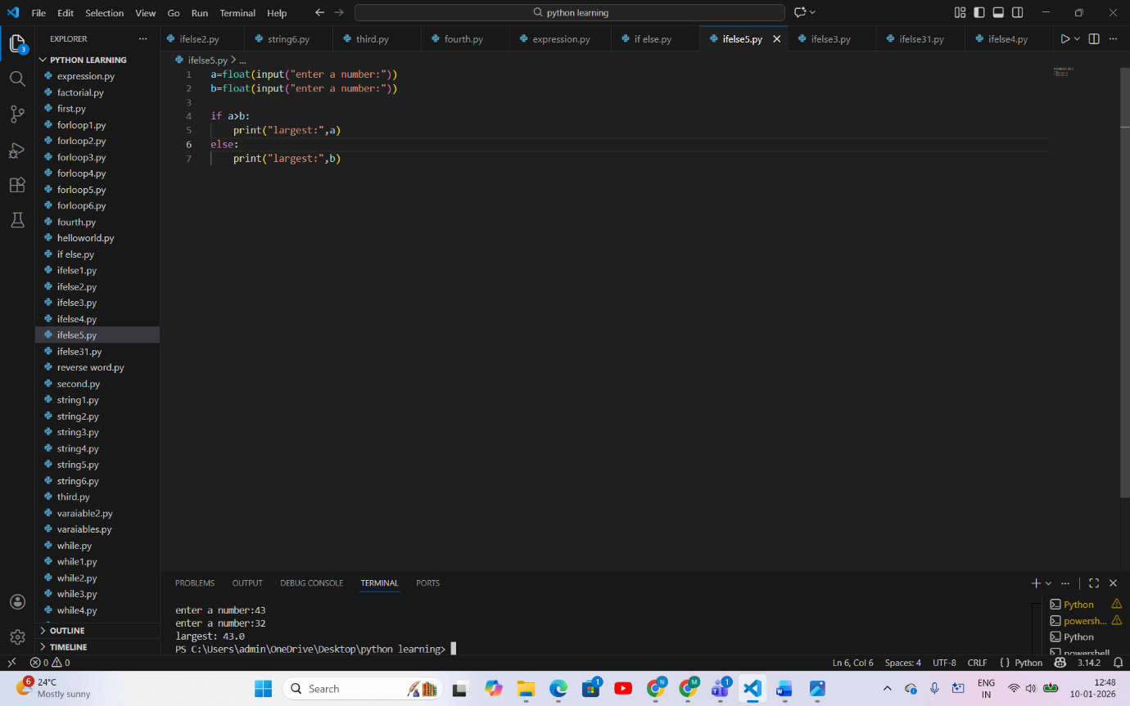
PSEUDOCODE
START
INPUT a
INPUT b

IF a > b
PRINT "largest:", a
ELSE
PRINT "largest:", b
END IF

END

FLOWCHART
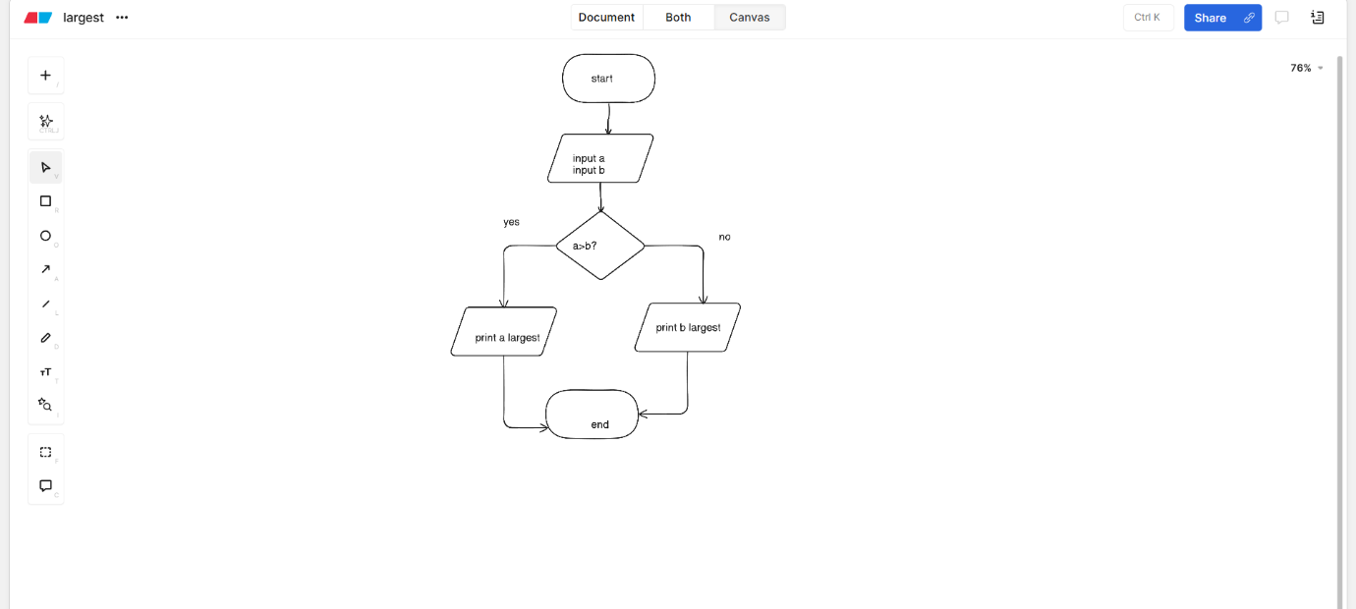
6.Print the number is divisible by 3&5
CODE&OUTPUT
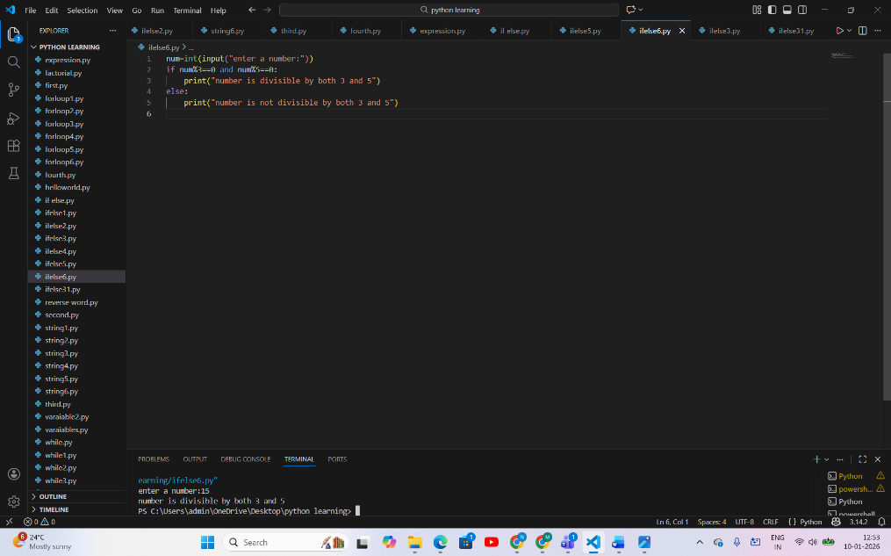

PSEUDOCODE
START
INPUT num

IF num divisible by 3 AND num divisible by 5
PRINT "number is divisible by both 3 and 5"
ELSE
PRINT "number is not divisible by both 3 and 5"
END IF

END

FLOWCHART
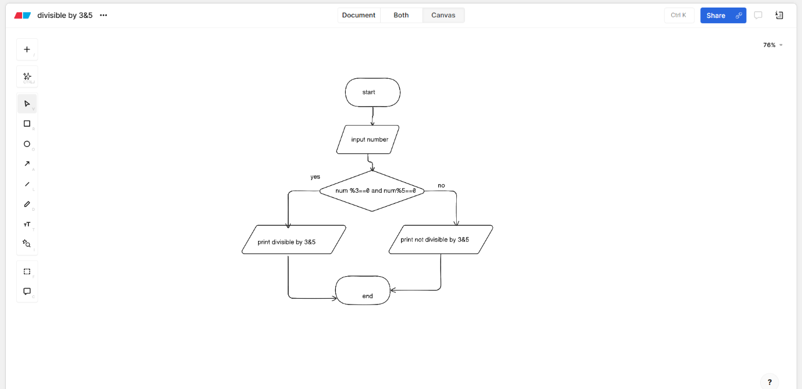
7.person eligible for vote or not using ifelse
CODE&OUTPUT
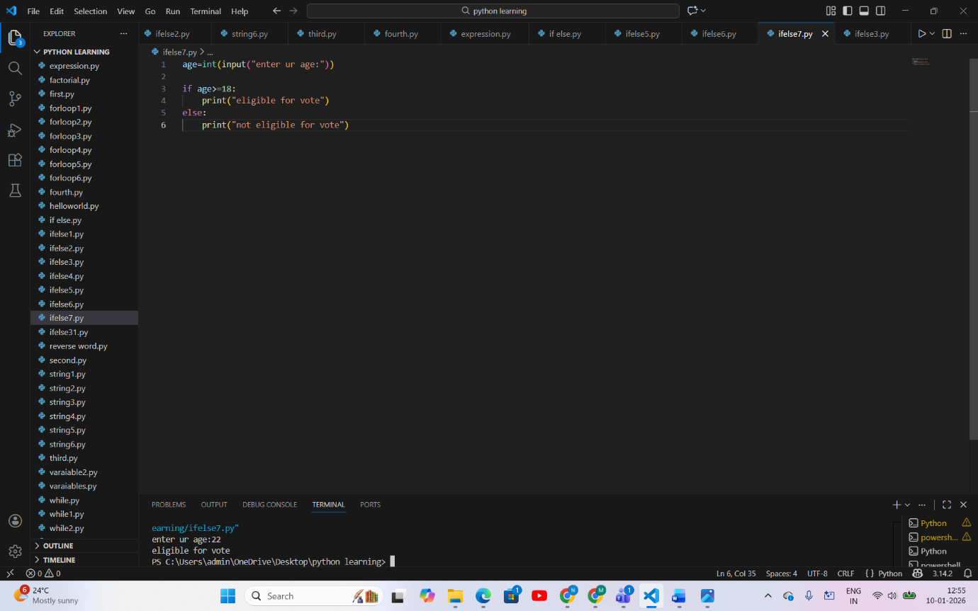
PSEUDOCODE
START
INPUT age

IF age ≥ 18
PRINT "eligible for vote"
ELSE
PRINT "not eligible for vote"
END IF

END

FLOWCHART
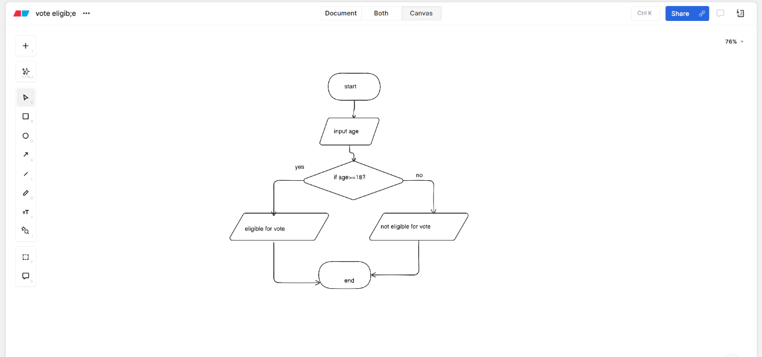

WHILE
1.Print numbers 1-10
CODE&OUTPUT
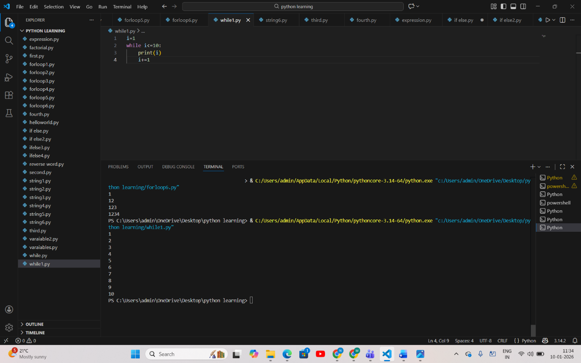
PSEUDOCODE
START
i ← 1

WHILE i ≤ 10
PRINT i
i ← i + 1
END WHILE

END

FLOWCHART
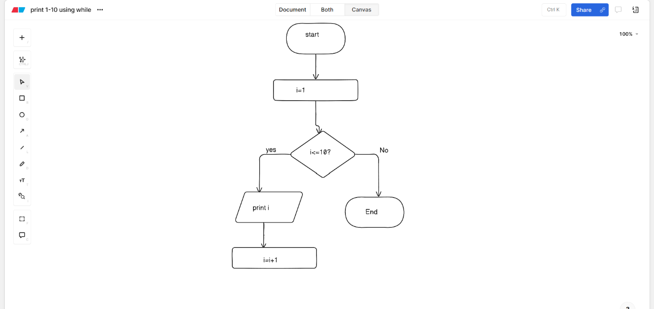
2 Print all even from 1-50 using while
CODE&OUTPUT
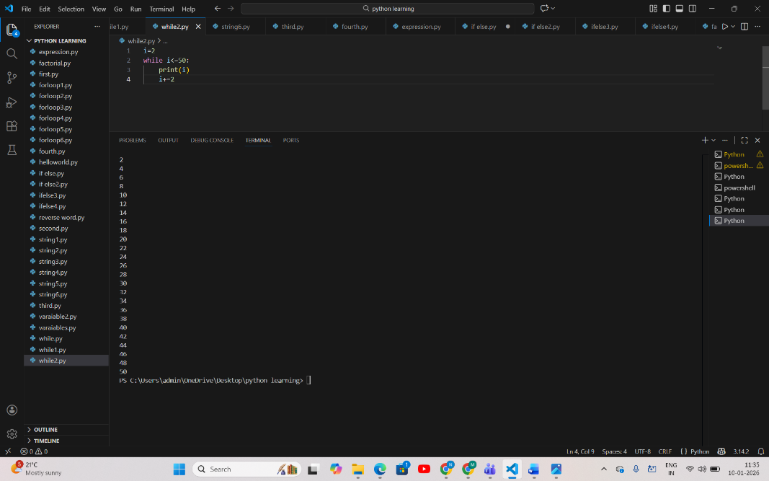
PSEUDOCODE
START
i ← 2

WHILE i ≤ 50
PRINT i
i ← i + 2
END WHILE

END

FLOWCHART
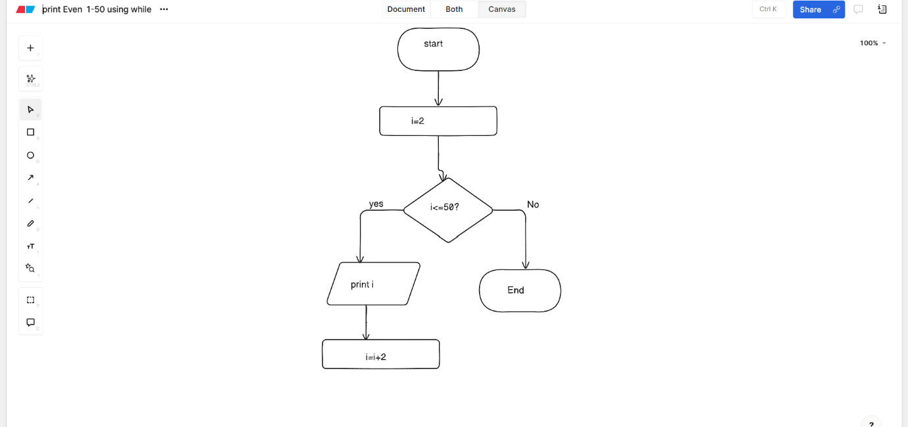

3.Print multiplication table
CODE&OUTPUT
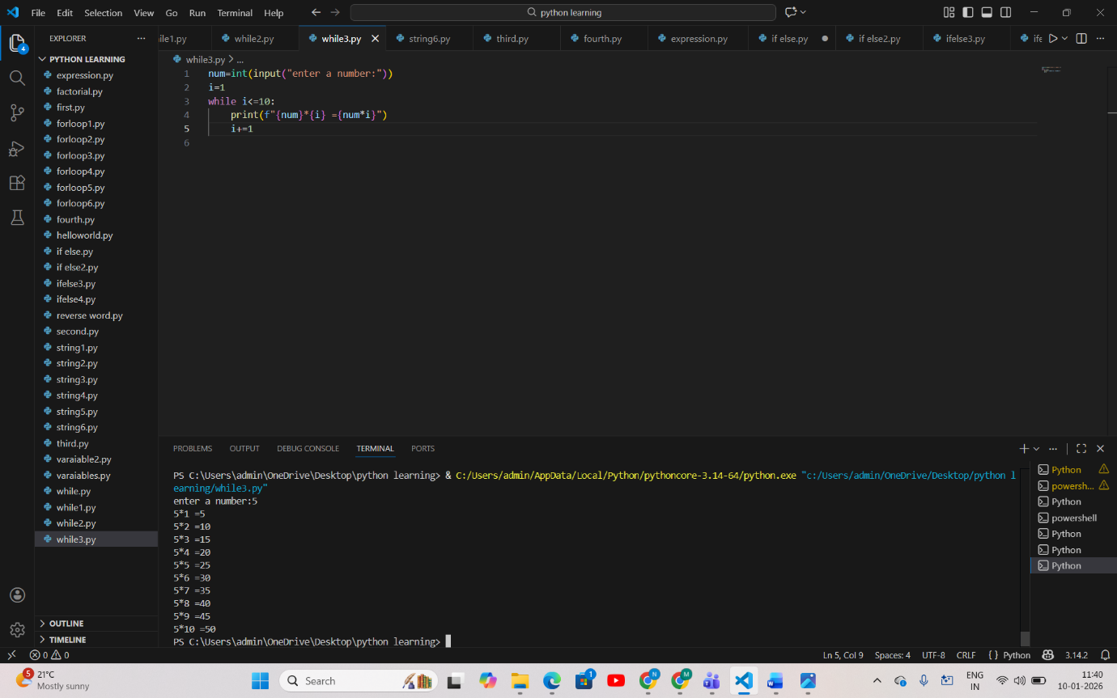
PSEUDOCODE
START
INPUT num
i ← 1

WHILE i ≤ 10
PRINT num * i
i ← i + 1
END WHILE

END

FLOWCHART
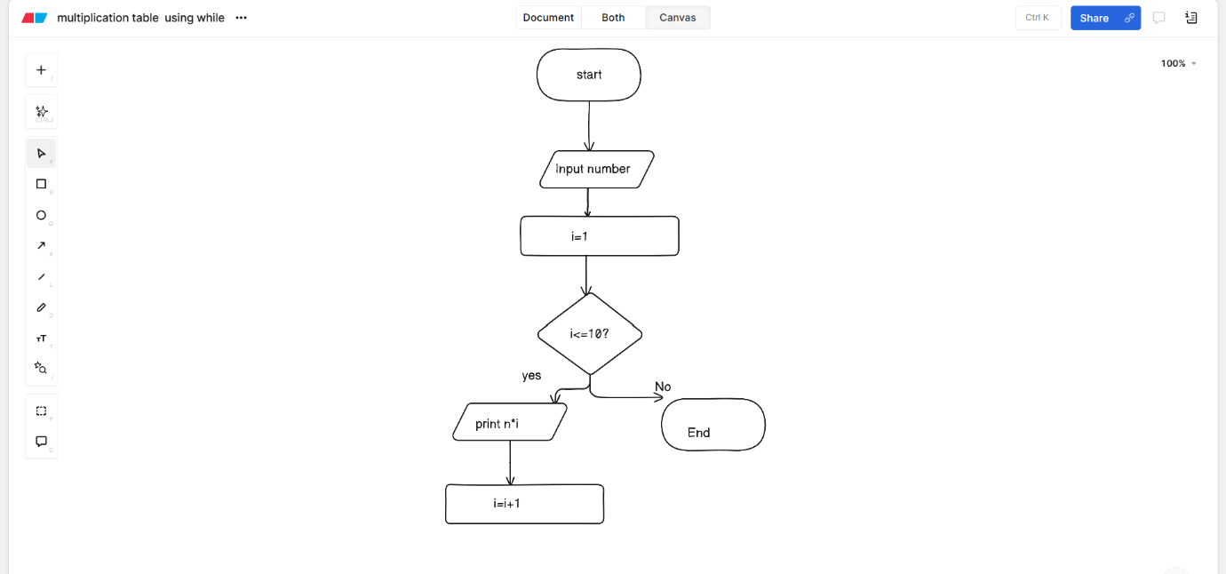
4.Sum of digits
CODE&OUTPUT
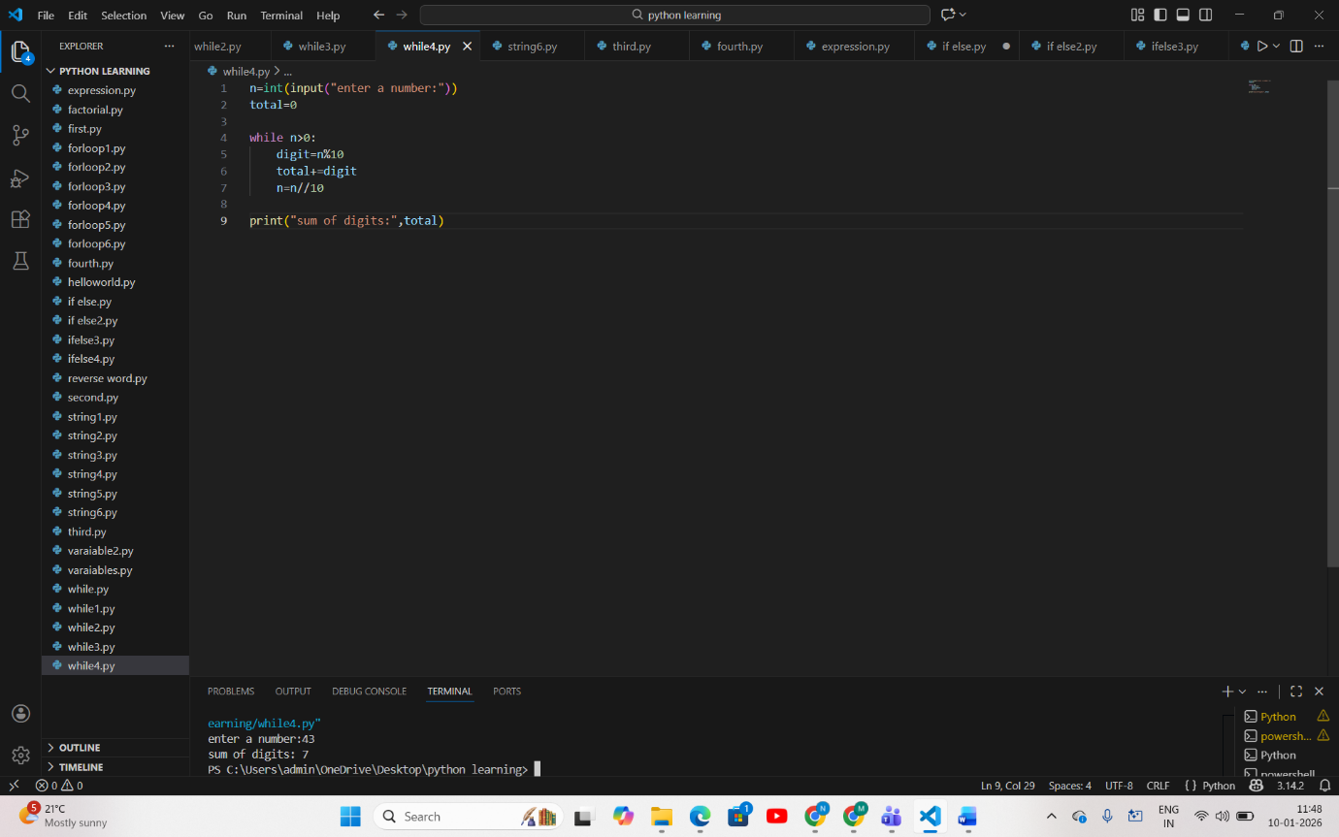
PSEUDOCODE
START
INPUT n
total ← 0

WHILE n > 0
digit ← n mod 10
total ← total + digit
n ← n ÷ 10
END WHILE

PRINT total
END

FLOWCHART
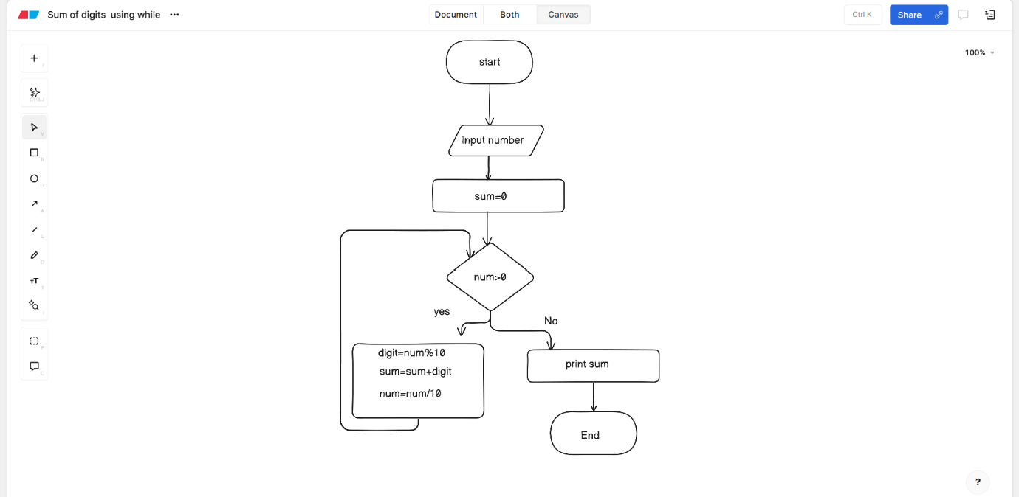

5,Reversed Number
CODE&OUTPUT
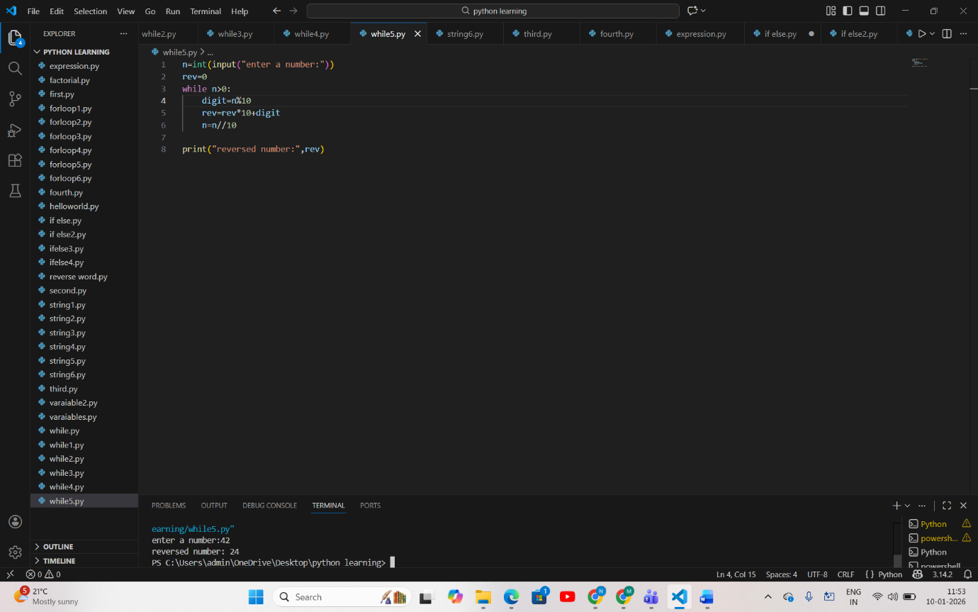
PSEUDOCODE
START
INPUT n
rev ← 0

WHILE n > 0
digit ← n mod 10
rev ← rev * 10 + digit
n ← n ÷ 10
END WHILE

PRINT rev
END

FLOWCHART
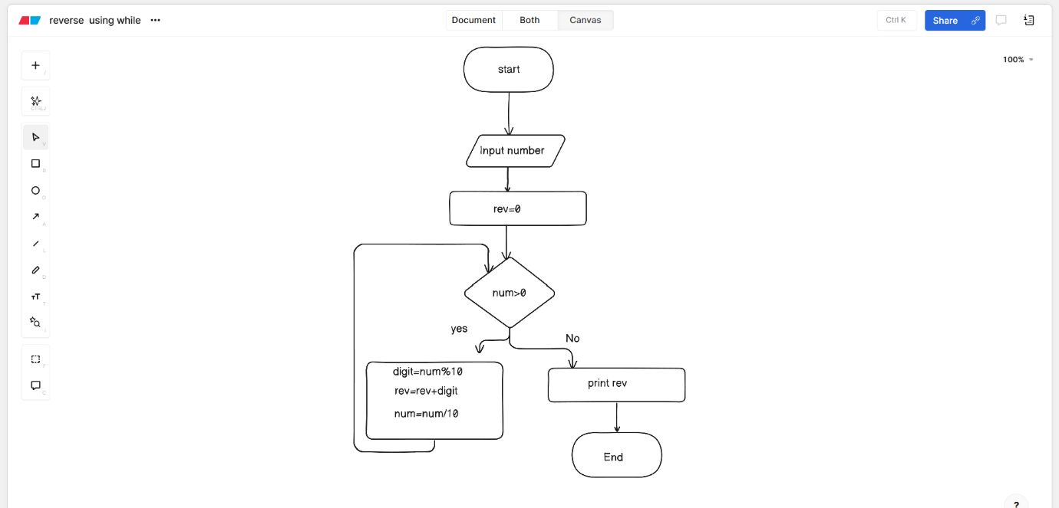
6.user enters a number it stops until user enter zero
CODE&OUTPUT
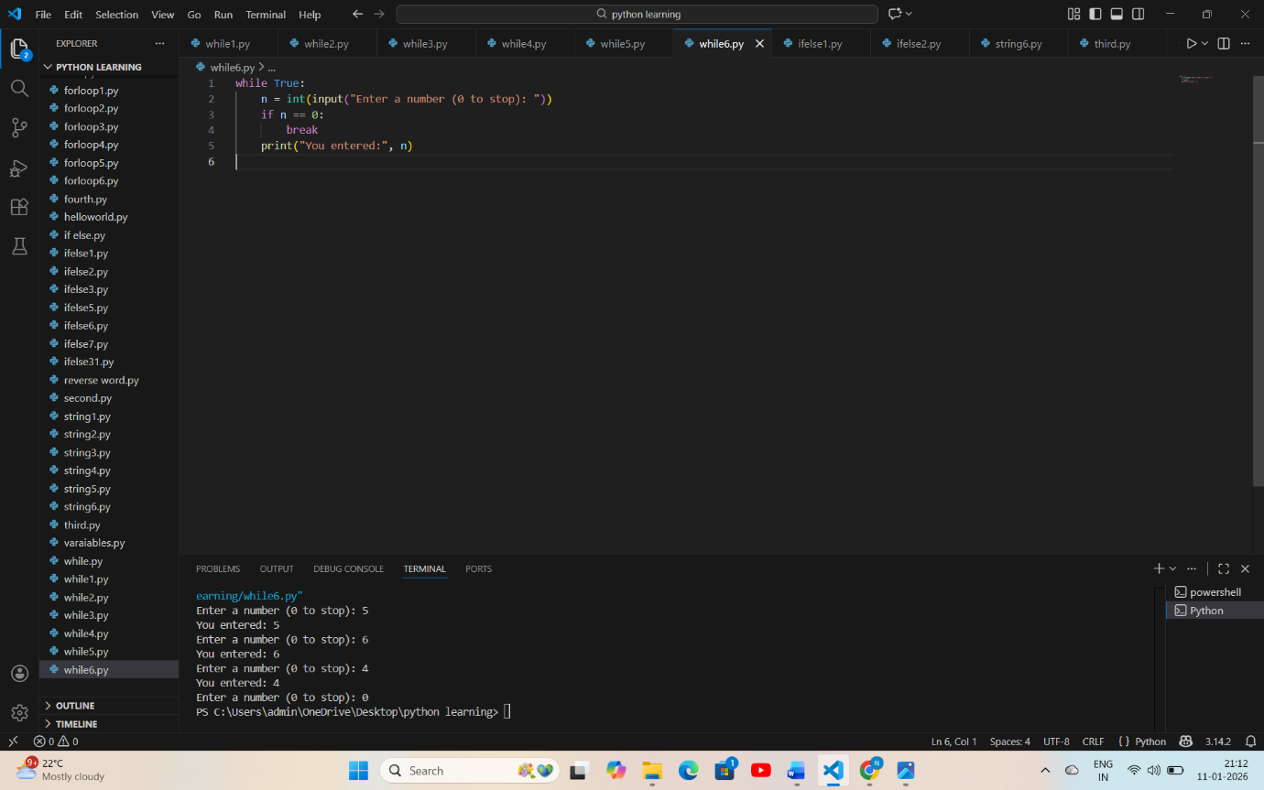
PSEUDOCODE
START

WHILE True
INPUT n
IF n = 0 THEN
BREAK
END IF
PRINT "You entered:", n
END WHILE

END

FLOWCHART
